**DeveLOPMENT PROGRAM - July 2015**

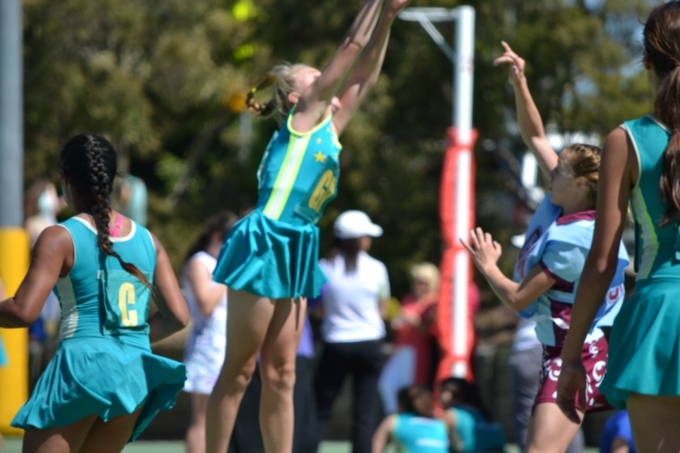**Dates: 9 & 10 July 2015**

**Location: Centenary High School Gym,**

**1 Moolanda Street, Jindalee**

**Age Group: 6-14 years (Born 2002-2009)**

**Cost: $30 for one session**

**$60 for both sessions**

**Program**

The development program will provide a range of on and off development opportunities to assist young players to develop their fundamental skills. The key aspects of this program include providing our junior players with a safe, fun atmosphere whilst at the same time developing their hand eye coordination, footwork patterns and specific skills for netball. Players will be coached to improve on existing skills, as well as master new skills to enhance their performance. At Joeys we are focused on ensuring all players have access to skill development.

**Head Coach**

Our Head Coach for this program is Tracey Jeanes-Fraser. Tracey Jeanes-Fraser is a well- respected netball coach with many years of success at an elite level. Some of her coaching experiences include:

* Australian Underage Lead Coach
* Queensland Academy of Sport Program Manager/Head Netball Coach
* Open, U21 and U19 Qld Netball Women’s Coach
* Qld Open Men’s Coach

She is currently the Queensland Women’s U21 Coach and Selector, Fusion Assistant Coach and has recently been involved in working with the Qld Australian Diamonds’ squad members. At a community level Tracey is involved in Netball for St Aidan’s Anglican Girls’ School in the QGSSSA competition and is a selector for Metropolitan West Senior School Netball. At St Joseph’s Tracey is our netta and A Grade coach and has also assisted with specialist sessions across all levels and age groups. She is currently the Director of Netball at St Aidan’s Anglican Girls’ School. Her expertise and enthusiasm for young players to achieve their goals has certainly been demonstrated by her successes in the netball sphere.

**Assistant Coaches**

Tracey Jeanes-Fraser will be assisted by current A Grade players, Joey’s Club coaches and WDNA Representative coaches.

|  |
| --- |
| ***If you would like to participate complete the registration form, deposit monies into the Joeys bank account and email to:*** [**stjosephsnetball@gmail.com**](mailto:stjosephsnetball@gmail.com)  ***For further information contact Bob Jeanes 0412 879 637 or Nicole Stallard 0418 413 672*** |

|  |  |  |  |  |  |  |  |
| --- | --- | --- | --- | --- | --- | --- | --- |
| **Registration Form** | | | | | | | |
| Name of Player | |  | | | Date of Birth | |  |
| Emergency Contact | |  | | | | | |
| Address |  | | | | | | |
| Email | |  | | | | | |
| Telephone | |  | Mobile | | |  | |
| **Medical Conditions (conditions, symptoms and treatment required)** | | | | | | | |
|  | | | | | | | |
| **Please tick which session(s) your child will be attending** | | | | | | | |
| **Born 2006-2009 - 9:30-11:30am**  **🞎 Thursday 9 July**  **🞎 Friday 10 July** | | | | **Born 2002-2005 – 12:30-2:30pm**  **🞎 Thursday 9 July**  **🞎 Friday 10 July** | | | |
| **Bank account details** | | | | | | | |
| Account Name – St Joseph’s Netball Club Bank – Bank of Queensland BSB – 124028 Account No – 20590212 Ref – **Player’s Name** Payment = $60.00 (payment to be deposited before Monday 6 July) | | | | | | | |